CIS 273 - Lab Assignment 9: JavaScript

Deliverable: Two (2) Web pages and one (1) Cascading Style Sheet (.css)

Complete the weekly lab based on the following:

- Write the code for each lab assignment.
- The code is to be submitted in a single compressed folder (zip file) to the online course shell. The file must contain all .htm files, along with any other files that may be necessary for your project to run (ex: text files, images, etc.).
- When saving the file, it should be saved as Lab_#_9 Maysonet_W.htm
- Any and all written answers must be entered into the online course shell with the submission of the attached lab assignment.

Follow the directions below to complete Lab Assignment 9:

- Create two (2) Web pages describing what is displayed and how.
- Create one (1) Cascading Style Sheet (.css) file with background color, font type, and font size, and assign it to both Web pages.
- On one Web page, add JavaScript that creates an effect on the whole page. Note: If you use the Internet for JavaScript samples, please use free or open source samples only.
- On the other Web page, add JavaScript that does something to the cursor. Note: If you use the Internet for JavaScript samples, please use free or open source samples only.

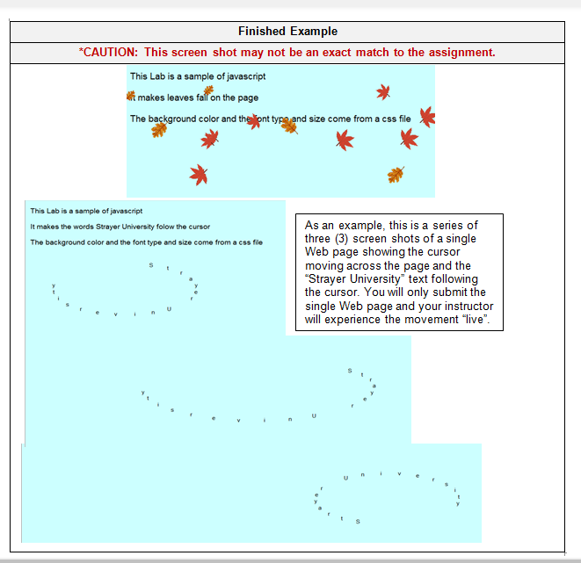

Lab Assignment 9: JavaScript
Criteria | 0 points  Unacceptable | 5 points  Developing | 10 points  Sufficient
1. Create two (2) Web pages describing what is displayed and how. | Did not complete. | Completed with errors. | Completed correctly.
2. Create one (1) Cascading Style Sheet (.css) file with background color, font type, and font size, and assign it to both Web pages. | Did not complete. | Completed with errors. | Completed correctly.
3. On one Web page, add JavaScript that creates an effect on the whole page. Note: If you use the Internet for JavaScript samples, please use free or open source samples only. | Did not complete. | Completed with errors. | Completed correctly.
4. On the other Web page, add JavaScript that does something to the cursor. Note: If you use the Internet for JavaScript samples, please use free or open source samples only. | Did not complete. | Completed with errors. | Completed correctly.

